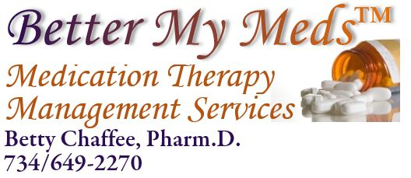

Dear Doctor,

Your patient, (date of birth ) has requested pharmacogenetic testing and counseling from BetterMyMeds, a local pharmacy practice specializing in Medication Management.

It is important that you are made aware of this request, as it may impact the use of certain medications either now or in the future. To that end, we are requesting that you write an order/prescription for the OneOme RightMed® test. A signed prescription assures me that you and your patient have talked about testing, and that you are aware of the plan.

After receiving your order for the OneOme RightMed® test, I will be responsible for helping your patient perform the cheek swab, shipping the sample, obtaining and interpreting the results, and meeting again with your patient to explain the results. A copy of the results and interpretation also will be provided to you, either by your patient or through the OneOme website.

If you don’t have easy access to paper prescriptions, testing can be authorized with your signature on this letter. Please also provide your printed name, address, and date below.

You can find more information about the OneOme RightMed® Pharmacogenetics test by going to www.OneOme.com . To learn more about BetterMyMeds and the Medication Management Services it provides, go to BetterMyMeds.com. Questions are also welcome at Betty@BetterMyMeds.com.

Thank you in advance,

Betty Chaffee, PharmD
BetterMyMeds
Dexter, MI
Betty@BetterMyMeds.com Authorization
Printed Name_______________________
Address___________________________
________________________________
Signature Date

