Atrial Fibrillation – What You Need to Know
Betty Chaffee/ September 26, 2022/ Medication Management/ 0 comments

Atrial fibrillation (AF, or afib) affects nearly 10% of adults over 65 and more than 15% of those over 70. It sometimes goes unnoticed, but noticed or not, it can be life-threatening. AF usually requires treatment with medications, so I'm often asked questions about it by my patients. In this post you'll learn what AF is, how to spot symptoms, why it's dangerous, and what you can do to keep yourself healthy.

What is atrial fibrillation?

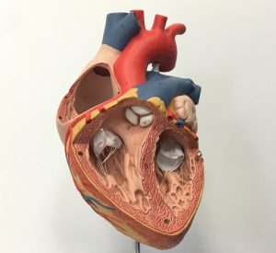
First, a little background. The heart has four chambers. The top two chambers are atria (each one on its own is an atrium). The two lower chambers are called ventricles. Typically an electrical impulse fires regularly in the right atrium to make both atria contract. Then that impulse travels down toward the ventricles, causing them to contract. In between, the blood pumped from the atria has time to fill up the ventricles, so that when they contract they pump blood vigorously and efficiently. All this happens on a regular basis, usually about 60-80 times per minute. Because it's so regular, blood flows smoothly from one chamber to the next, then is pumped into the body to feed oxygen and other nutrients to all of our organs.

But sometimes that electrical impulse stops firing regularly. When that happens, the atria don't contract regularly, and the impulse doesn't reach the ventricles on a regular basis. The atria might just quiver, or contract at random times. That's called fibrillation. See what it looks like here.

During atrial fibrillation, the ventricles don't get their usual and regular jolt (if you will) to contract. So the ventricles may start beating way too fast, or too slow, or completely randomly. Amazingly, they do continue to beat and force blood to the rest of the body -- a testament to how resilient the heart is. And in many cases, the ventricles continue to beat regularly, even at usual rates, despite the randomness of the atria's electrical impulses.

What are the symptoms?

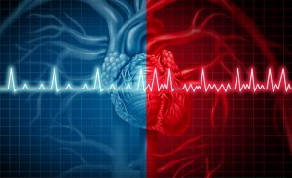
When the chambers of the heart don't beat in sync, the ventricles may not pump blood efficiently. By contracting way too often, they don't have time to fill up with blood before pumping it out. That results in less oxygen getting to other tissues in the body. So you might feel lightheaded, dizzy, tired, or short of breath. You might feel your heart pounding, beating too fast, or even have chest pain. When the heart continues to work that hard, it can tire out -- the beginnings of heart failure.

But remember, sometimes the ventricles continue beating regularly, even at normal rates. In that case, you could have atrial fibrillation, but notice no symptoms at all.

Why is atrial fibrillation dangerous?

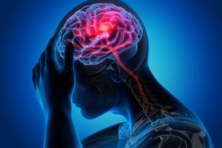
One of the biggest dangers of atrial fibrillation is stroke. The risk of stroke is about 5 times greater in people with AF than in those without. And this is true whether or not atrial fibrillation results in symptoms! Here's why: when the atria don't contract regularly the blood inside them doesn't flow smoothly. Some gets pumped to the ventricles, but some just stays where it's at. And we know what happens when blood stays where it's at -- think of blood escaping from a cut or scrape you had recently. When it sits, it begins to coagulate. When blood doesn't flow smoothly and regularly out of the atria, it can begin to form tiny clots. Those clots can then travel to the brain, causing stroke.

The danger of stroke is real. Of all the concerns about AF, this is the one that can cause the most life-altering (or life-ending) consequences. The high risk of stroke is the reason that September is Atrial Fibrillation Awareness month.

What treatments are available?

There are surgical and non-surgical treatments that can restore the regular rhythm of the heart in many people. When successful, these procedures completely remove the dangers posed by AF. But not everyone responds well to these procedures. When procedures aren't effective, we turn to medications.

Lowering the risk of stroke

One of the most important uses of medications in AF is to decrease the risk of stroke. Medications that keep the blood from forming those tiny clots we talked about are known as blood thinners, or anticoagulants. They include aspirin, warfarin (Coumadin), rivaroxaban (Xarelto), and apixaban (Eliquis). Nearly everyone with chronic AF can benefit from these medications, though some patients at extremely low risk of stroke may do well without them.

Anticoagulant medications generally must be used lifelong. Because they decrease the formation of clots that may cause stroke, they also increase the risk for other types of bleeding. The risk of serious bleeding after an injury, even a mild one like bumping into a coffee table, is higher. So it's important to think carefully about possible dangers such as ladders, sharp knives, and other things that are otherwise routine. It doesn't mean life has to change radically, but it does mean thinking carefully before acting.

If you've taken warfarin before, or know someone who has, you know that it requires some meal planning as well. Vitamin K, present in many vegetables, multivitamins, and other foods, interacts with warfarin. That doesn't mean you can't eat any of those foods, but it does mean that being consistent in how much you eat is important. Just like thinking carefully about dangers, thinking carefully about diet needs to become part of the routine. Warfarin also requires frequent lab monitoring.

The newer anticoagulants, Xarelto and Eliquis, are convenient to use, and very effective. No dietary restrictions, no frequent lab monitoring. But they can be quite expensive if not covered by your prescription insurance.

Controlling the heart rhythm and rate

A number of medications can be used to make sure the heart continues to pump blood efficiently. While the heart is still in AF, medications can be used to keep the ventricles from beating too fast. By keeping the rate in a safe range, the ventricles will fill with enough blood between beats to efficiently feed the rest of the body.

There are also medications that can be used to restore the electrical impulses to normal. When effective, these medications can sometimes restore the regular heart rhythm.

Awareness is important, but are you at risk?

Now that you know what atrial fibrillation is and that treatment provides protection, it's also important to know whether you're at higher risk than most. There are a number of risk factors -- many of which we can't control, but some that we can.

Better My Meds is dedicated to helping you stay as healthy as possible. Knowing the symptoms of AF and what to expect if it's diagnosed will help you do just that. Please share your questions and comments with other readers in the space below. Or contact us directly at Better My Meds -- we love hearing from you!

Betty Chaffee, PharmD, is owner and sole proprietor of BetterMyMeds, a Medication Management service devoted to helping people get the maximum benefit from their medications.

