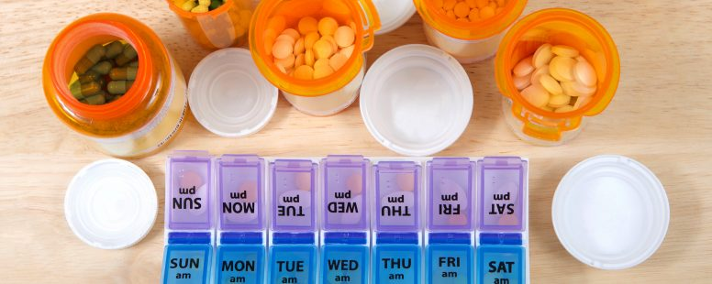

Do I Really Need All These Meds?
Betty Chaffee/ January 17, 2023/ Deprescribing, Medication Management, Medication Therapy Management/ 2 comments

That’s one of the most common questions I hear. Sometimes people say it jokingly, as if they believe there’s no going back. Other times people say it out of frustration — they’re tired of getting prescriptions filled over and over, filling medication organizers, taking a handful of pills at a time, and looking at money fly out of their bank accounts.

Whatever the reason for the question, it’s obvious that taking a large number of medications is a common concern. How do we get to that point? And once we’re there, is there any going back? Let’s tackle those questions, one at a time.

Why do prescription (and nonprescription) medicines pile up over the years?

As we age we’re more likely to be diagnosed with chronic health problems. And as those health problems pile up, treatments for them pile up, too. Very often, those treatments involve medications that have been shown to improve health outcomes. So we may start out with a medication for high blood pressure, then have a diabetes med added. Next thing, we need a med for cholesterol or osteoarthritis. Our doctors are simply using evidence-based information to help us stay as healthy as possible.

Another common reason: medicines that work differently may be used for the same condition. In some cases, using two medications that work in different ways provides better health outcomes than just using one.

We often want to put the blame on our doctors for prescribing so many medications. But sometimes it’s our own choice. Have you started taking dietary supplements or nonprescription medicines that your doctor didn’t recommend? You may consider them safer (which may or may not be true) or be more willing to take them because it was your own choice. But in the end, they still add to what’s called the “pill burden”.

So there are very good reasons you may have found yourself taking more medications than you ever imagined. Now the question is…..

Do you really need to keep taking all those meds?

In many situations, the answer is “maybe not”. Sometimes, as in the case of supplements or nonprescription medications, you get to make that decision all by yourself. When it comes to prescription medications, that decision should be made by you and your prescriber together.

Most doctors and other prescribers are really good at prescribing medications to treat chronic diseases and uncomfortable symptoms. But given their limited time, they don’t always think about “deprescribing” when those meds aren’t needed anymore. Many doctors are happy to consider lowering doses or stopping medications when their patients bring up the subject. So if it’s important to you, it’s your job to let your doctor know!

But how to start the conversation? Leading with “do I really need all these meds?” may not be the best way to start. It’s a broad topic and may take more time than your doctor has. Armed with some information, though, you can narrow it down so that you and your doctor can make a plan. Where can you get the information that’ll help you communicate easily with your doctor?

Start with your pharmacist!

First, find a pharmacist who will meet one-on-one to go through all of your medications and health concerns. If you have Medicare Part D prescription insurance you may be eligible to have that appointment at no out-of-pocket cost. But even if it’s not a covered benefit, the value to your health and pocketbook will be well worth the cost. If your pharmacy doesn’t provide that service, contact us at Better My Meds, where the focus is on helping you get the best health outcomes from your medications. That includes making sure you’re not taking more medications than you need.

At your appointment, your pharmacist will ask about every medication you take (prescription, nonprescription, vitamins and supplements). What dose do you take? What are you taking it for? Is it working for you? Are you having side effects or problems with drug interactions?

Together, you and your pharmacist will identify those medications that are vital to your health, as well as those that may not be doing their job, may be causing more harm than good, or simply may not be necessary any more. You’ll come up with a plan to talk with your doctor about the medications of most concern, to start down the road of paring your med list down to just those that are serving you well.

It’s important to keep in mind that you may find out every medication you take is important to your health. Sometimes the med list gets long simply because it’s needed to give you the best health outcomes. But more often than not, there’s at least one medication on the list that’s worth talking about with your doctor.

Your pharmacist can help you work more easily with your doctor

Don’t wait! Make 2023 the year you learn whether you really do need all those meds. And then continue to use your pharmacist for information, so those meds don’t pile up needlessly again.

As always, please leave your questions and comments in the space below. Or contact us directly at Better My Meds. We enjoy hearing from you!

Betty Chaffee, PharmD, is owner and sole proprietor of BetterMyMeds, a Medication Management service devoted to helping people get the maximum benefit from their medications.
Share this...

