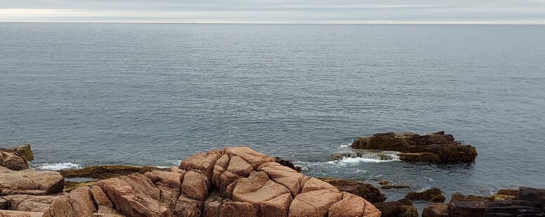
Stress Reduction, Relaxation, and Adventure in the Northeast US!
Betty Chaffee/ September 21, 2023/ Medication Management/ 0 comments

Better My Meds is all about using non-medication strategies to prevent and treat chronic health problems. Taking time off for relaxation and stress reduction is one of those strategies. That, plus you haven’t heard from me in a few weeks. So this post will be a brief way to 1) tell you what I’ve been up to and 2) remind all of us that “down” time is important to our health!

The Northeast United States

My husband and I had never been east of New York or north of Massachusetts. So Maine's been on our bucket list for several years. We finally decided to take a two-week road trip to see what the northeast is all about.

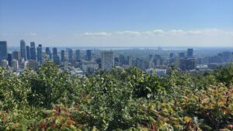
We loaded up our bikes, hiking shoes, books, and lawn chairs (along with plenty of clothes and a cooler full of food). Booked lodging along the way and set off the day before Labor Day. Having never been north of Toronto in the past either, we started our adventure in Montreal. Little did we know that Labor Day is celebrated there, too! So we joined lots of crowds on the roads, in the city, and especially in the beautiful park. Mount Royal Park contains the highest point in Montreal, and getting to the top used lots of energy. But the view!

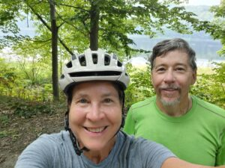
It didn't take long to drive from Montreal, across the border to Maine. There’s so much to see there! Rocky, jagged coastline, mountains, bays, national parks. Our week in Mainestarted in Augusta, where was quite hot and humid the first few days. But we found a rails-to-trails route that followed the Kennebec River and cycles in the cool mornings. Afternoons were filled with visiting nearby parks for sightseeing, hiking, and even just relaxing for an afternoon by water’s edge.

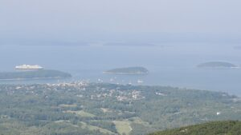
Next stop was Bar Harbor, where we stayed right in town for a few nights. Acadia National Park is huge, with so much to do. We drove to the summit of Cadillac Mountain (you’d have to be VERY dedicated to ride a bike up there!). Looking down we could see all of the islands covered in clouds and mist. It was fascinating and beautiful.

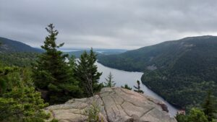
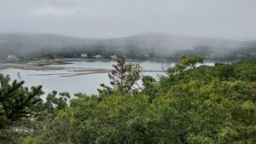

We found the “bar” that Bar Harbor is named for, and at low tide walked from town to Bar island, along with lots of other tourists. Road our bikes on the Carriage Road in the National Park, and hiked up to the summits of both the South Bubble and the North Bubble. The United States has so much varied landscape!

Avoiding Hurricane Lee

We would have loved to stay longer, but rain was predicted, and Hurricane Lee was heading up the east coast. We left Maine and headed over to New Hampshire. Full disclosure – I may be very good helping you get the best health outcomes from your medications, but I’m awful at geography and history. It’s a humbling experience when you realize you booked a stay in Concord NH, thinking it was the revolutionary war Concord (which, of course, most people know is in Massachusetts). So there we were in Concord NH without a clear idea of what to do. But we found a bike route to enjoy, explored town, and had time to just sit and relax when it rained in the afternoon. So all was not lost!

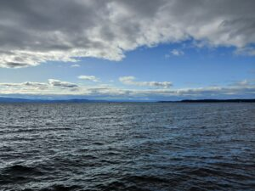
On to Burlington, VT, for a day. There's a popular multi-use trail that goes long the shore of Lake Champlain. We biked along the trail for about 17 miles, joining many other people who were enjoying the lake and the late summer evening, I was astounded at the size and beauty of the lake. It was sunny and warm that evening, with a brisk wind coming off the lake that gave us a run for our money.
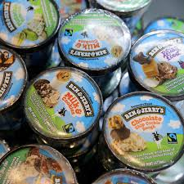

But then – Ben and Jerry’s Ice Cream! Ben and Jerry's was founded in Burlington, and I can assure you that I did NOT make a mistake when I booked that stay!

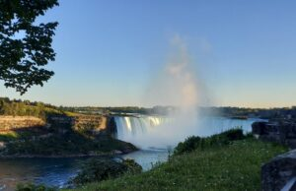
Our drive back to Michigan took us through Canada, and this time we stayed in Niagara Falls, Ontario. We’d been there briefly some years ago, but it was very early spring, snow on the ground and lots of fog (along with mist from the falls). So it was hard to appreciate the beauty. This time the weather was clear and sunny, we had plenty of time to walk and explore, and take lots of photos!

So, now, back to “real life”. It can be tough jumping back into the normal daily rhythm. But the adventure, change in routine, and rest and relaxation provided a nice break. A chance to think about life, and how work and pleasure can co-exist. Our two-week road trip was a breath of fresh air, in more ways than one. And I’m happy and excited to get back to the work of Better My Meds, and helping you get the best value out of your medications!

If you’ve ever been to the northeast US, or on any vacation that was special to you, please feel free to share your experiences in the comment section below. And you can always contact us directly at Better My Meds. We love hearing from you!
Download printable version
Betty Chaffee, PharmD, is owner and sole proprietor of BetterMyMeds, a Medication Management service devoted to helping people get the maximum benefit from their medications.

