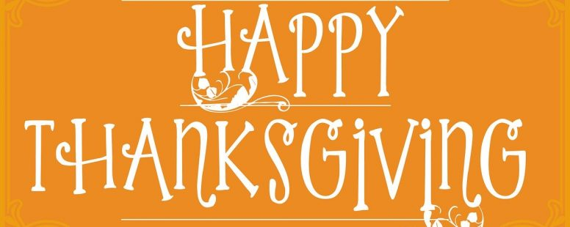

Thanks to You, the Friends of Better My Meds
Betty Chaffee/ November 21, 2023/ Medication Management/ 0 comments

I’ve been hearing lots of people (including myself) say it feels crazy that It’s nearly the end of November already. Somehow this year seems to have flown by. And now Thanksgiving is upon us. So instead of talking about a health-related topic, I’m devoting this post to you, the readers and supporters of Better My Meds. I’m thankful for all of you who read these posts, call me for information and advice, attend local programs where I speak. Better My Meds wouldn’t be in existence without you.

Better My Meds was founded when I realized people like you didn’t have access to the full spectrum of healthcare pharmacists can provide. Pharmacists fill prescriptions, of course, and that’s really important. But knowledge about meds, and support in reaching your healthcare goals is critical. Pharmacists are a great resource to provide that knowledge and support. But traditional community pharmacy practice seemed determined to keep us from doing it.

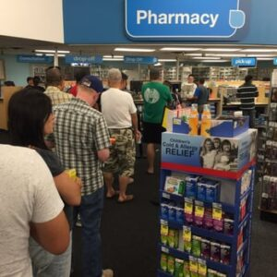
Community pharmacists have been pushed further and further away from patients in many stores. So far that most of their customers probably don’t know they’re full of helpful information. One big reason is that insurers (helped by pharmacy benefit managers, or PBMs) require pharmacies to fill prescriptions for very little profit. Did you know that prescriptions are often filled at a loss to the pharmacy? Because margins are slim, pharmacy owners can typically afford to hire just enough pharmacists to get the prescriptions out the door. And you’ve probably heard that sometimes there aren’t even enough pharmacists to do that safely. Recently, Kaiser Permanente, Walgreens, CVS, and others have been criticized by their employees for putting patient safety at risk.

That’s why Better My Meds is going in a different direction. We provide the education and support you need to get the best health benefit from your meds. And many of you have told me you feel more “in charge” of your health because of it. That you’re able to have better conversations with your doctors. That you’re more confident making healthcare decisions. Maybe you started taking a medication you were wary of, and your health is improved. Or talked with your doctor who agreed to stop a med you don’t need anymore. You saw the value Better My Meds offered and took advantage of it. And I thank you for that.

It’s slow going, building a healthcare practice that no one has ever heard of before. But Better My Meds is gaining traction, thanks to all of you. You’ve seen the benefit of adding a pharmacist to your healthcare team. And you’ve told others about it – word of mouth is so valuable!

So this Thanksgiving season, I thank you from the bottom of my heart. You’ve made 2023 a great year for Better My Meds. I hope I’ve been able to do a little of the same for you. May you enjoy the holiday with people you love (and lots of pie!). And may you find many things to be thankful for!

About Betty Chaffee
Betty Chaffee, PharmD, is owner and sole proprietor of BetterMyMeds, a Medication Management service devoted to helping people get the maximum benefit from their medications.

