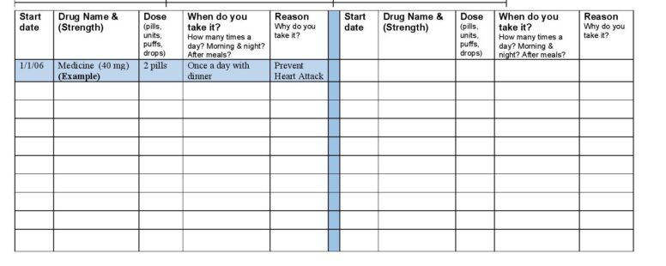
Is Your Medication List Up-to-Date?
Betty Chaffee/ January 25, 2024/ Medication Management, Medication Therapy Management, Self management/ 0 comments

This is the second post in a series about Medication Management, DIY style. Many of you know that Better My Meds is a pharmacy practice that focuses on Medication Management. But what we do is just a piece of the pie. You also have a role in managing your medications. A big one, actually, since you’re the end user. In our last post we talked about the importance of using a medication organizer and having your meds all refilled at the same time. Those strategies go a long way to making your meds easier to manage. This post will focus on the importance of an accurate, complete, and up-to-date medication list.

Who is responsible for keeping your medication list updated?

Short answer – YOU. (Of course, there’s more to it than that.)

Your doctor’s staff strives to keep an accurate list of your medications. But despite their best efforts, I’ll bet you often find that meds stay on the list when they’ve been stopped. Or meds you told them you chose to take on your own aren’t listed. Your doctor may have told you to only take a half tablet instead of a whole tablet, but that’s not reflected on the list. There are lots of reasons those med lists aren’t always accurate, and health systems are trying to fix it. But for the foreseeable future, you cannot count on your medical record to have an accurate med list.

The more important point though, is that YOU are the only one who knows for sure what meds you take. Your doctor knows what was prescribed, but doesn’t know for sure that you take those meds, or take them as prescribed. And your doctor may not know what nonprescription medications and dietary supplements you’ve chosen to take on your own. Same with your pharmacy - they know what they dispensed, but not what you may have had filled at a different pharmacy, or purchased over the counter.

You are the expert on your medication list. As an active player on your healthcare team, you are the obvious person to be the list-keeper!

Why does it matter?

Many health professionals need to know what medications you take so they can provide the best care. And if you need emergency care, or need to be hospitalized, a complete list of meds will go a long way to keep you safe and get you healthy. Having that list handy and sharing it with providers will make healthcare encounters of all kinds simpler and safer.

So make a medication list!

Gather all your medications and supplements. Don’t forget inhalers, creams, and other items that aren’t in a prescription bottle.

For each medication, write down its name, strength, how many you take at a time, what time(s) of day you take it, and why you take it.

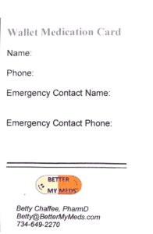
For those of you who like written, wallet-size lists, download this wallet medication card from the Better My Meds website. (It’s actually pretty neat- if you print pages 1 and 2 double-sided, you end up with two med cards, one on top of the other, just cut it down the middle and fold them up!)

If you prefer keeping documents on the computer, the FDA and AHRQ both have templates you can try out.

Be sure to keep the list where you can remember to take it to medical appointments. And be sure it’s accessible to emergency personnel just in case!

Now for the hard part – keeping it updated

Make a regular date with yourself to review your list, and put it on your calendar. After every medical appointment, once every three months -- whatever works for you. Review the list, and change any entries you need to.

Those of you who’ve chosen the computerized version will have it a little easier here – a couple of clicks and keystrokes will be all you need. If you’re using the written wallet med card you may have a bit more transcribing to do. But the trade-off is that the card will fit in your wallet, where the computerized lists will be a larger piece of paper that’s a bit bulkier. Nothing’s perfect, right?

And remember, Better My Meds is here to help!

One of the first things we do at new patient appointments is to make a complete and accurate medication list. And while we’re doing that we often find that it’s unclear whether all the medications are still needed, or what the dose really should be. Putting a list together helps to identify questions that you may not have known you had. It’s a great start to getting the best health outcomes from the medications you take!
Betty Chaffee, PharmD, is owner and sole proprietor of BetterMyMeds, a Medication Management service devoted to helping people get the maximum benefit from their medications.

